**TIC TAC TOE**

**A PROJECT REPORT**

***Submitted by***

# AMIT KUMAR SAMAL (230720100157)

***in partial fulfilment for the award of the degree of***

**MASTERS**

***in***

# COMPUTER APPLICATION(MCA)



**SCHOOL OF ENGINEERING AND TECHNOLOGY**

**BHUBANESWAR CAMPUS**  **CENTURION UNIVERSITY OF**

**TECHNOLOGY AND MANAGEMENT**

**ODISHA**

**BONAFIDE CERTIFICATE**

Certified that this project report **“TIC TAC TOE”** is the bonafide work of “SARMISTA PANDA (230720100238)” who carried out the project work.

Under my supervision. This is to further certify to the best of my knowledge that this project has not been carried out earlier in this institute and the university.

**SIGNATURE**

**HARAPRIYA SENAPATI**

**Associate professor of Engineering and Technology**

*Certified that the above-mentioned project has been duly carried out as per the norms of the college and statutes of the university.*

**SIGNATURE Prof. Rakesh Ray**

**HEAD OF THE DEPARTMENT**

**Professor of Engineering & Technology**

DEPARTMENT SEAL

## DECLARATION

I hereby declare that the project entitled “**TIC TAC TOE”** submitted for the project of 1st semester Master of computer application is my original work and the project has not formed the basis for the award of any Degree / Diploma or any other similar titles in any other University / Institute.

**Name of the Student: - AMIT KUMAR SAMAL**

**Signature of the Student: RegistrationNo: - 230720100157** **Place:**

**Date:**

## ACKNOWLEDGEMENTS

I wish to express my profound and sincere gratitude to, Harapriya Senapati.

Department of Computer science and Engineering, SOET, Bhubaneswar Campus, who guided me into the intricacies of this project nonchalantly with matchless magnanimity.

I thank Prof. Rakesh ray, Head of the Dept. of Department of Computer

Science Engineering, SoET, Bhubaneswar Campus and Dr. Sujata Chakravarty, Dean, School of Engineering and Technology, Bhubaneswar Campus for extending their support during Course of this investigation.

I would be failing in my duty if I don’t acknowledge the cooperation rendered during various stages of image interpretation.

I am highly grateful to my group Members, who evinced keen interest and invaluable support in the progress and successful completion of my project work.

I am indebted to my parents for their constant encouragement, co-operation and help. Words of gratitude are not enough to describe the accommodation and fortitude which they have shown throughout my endeavor.

**Name of the Student: - AMIT KUMAR SAMAL**

**Signature of the Student: Registration No: - 230720100157**

**Place:**

**Date:**

**Content :**

* **Introduction**
* **Objective**
* **Requirements**
* **About C**
* **Source Code**
* **Output**
* **Conclusion**
* **References**

**INTRODUCTION**

People began to show interest in using their computers as a source of entertainment in the 1970s, resulting in the emergence of a multibillion-dollar game business. The origin is uncertain, though ancient Egyptians claim to have discovered the Tic-Tac-Toe pattern etched on rocks around 3500 years ago. Later, they discovered how much fun it was to play a game using this pattern. The game became popular after that, and it could be played on a wooden board, a table, or even a piece of paper. Tic-Tac-Toe is a popular board game in which two players alternately place X’s and O’s on a 3x3 grid. The players must first pick who would go first and who will record his actions with an X. The game continues with the opponents placing their marks on any unoccupied cell. The goal of the game is for the first player to collect three marks in a row, which might be vertical, horizontal, or diagonal. If all of the cells are filled, the game ends in a tie. Using the C programming language, we created a two-person tic tac toe game in which the player who forms a horizontal, vertical, or diagonal sequence of three marks wins. When a player is successful in forming a vertical, diagonal or horizontal sequence of either X or 0, the game declares the winner. The system has been designed in such a way that the 3X3 grid will be displayed first along with the positions on each square. The first player will then have to enter theposition in which he/she wants to place the mark in. The turns are toggled until any one of the player is successful in making a sequence of 3 consecutive marks either vertically, horizontally or diagonally. And finally the winner is declared.

# ABSTRACT

The square block (3 x 3) can be filled with a cross (X) or a circle (O) in the TicTac-Toe game, which can be played by two players (O). By allowing each player to mark their move, the game will switch between the players. When one of the players makes a horizontal, vertical, or diagonal line with three identical markers, the program displays which player has won, whether X or O. The game is constructed such that two players can play tic-tac-toe by entering the position to place their marks on the board. The software will have a display function and a select function for placing the symbol as well as a toggle function for switching between the symbols, allowing each participant to take a turn playing the game. After each player makes a move, the computer will update and check for game circumstances as the game progresses.

# REQUIREMENTS

**Hardware Requirements :**

1. **Monitor**
2. **CPU ( Central Processing Unit )**
3. **Keyboard**
4. **Mouse**

**Software Requirements :**

1. **OS ( Operating System ) – Windows 11**
2. **Dev C ++**
3. **GCC Compiler**

# ABOUT C

C is a general-purpose, imperative computer programming language supporting structured programming, lexical variable scope, and recursion, while a static type system prevents unintended operations. By design, C provides constructs that map efficiently to typical machine instructions, and has found lasting use in applications previously coded in assembly language. Such applications include operating systems, as well as various application software for computers ranging from supercomputers to embedded systems.

C was originally developed at Bell Labs by Dennis Ritchie between 1972 and 1973 to make utilities running on UNIX. Later, it was applied to re-implementing the kernel of the UNIX operating system. During the 1980s, C gradually gained popularity. Nowadays, it is one of the most widely used programming languages, with C compilers from various vendors available for the majority of existing computer architectures and operating systems. C has been standardized by the American National Standards Institute since 1989 and subsequently by the International Organization for Standardization.

C is an imperative procedural language. It was designed to be compiled using a relatively straightforward compiler, to provide low-level access to memory, to provide language constructs that map efficiently to machine instructions, and to require minimal runtime support. Despite its low-level capabilities, the language was designed to encourage cross-platform programming. A standards-compliant C program that is written with portability in mind can be compiled for a wide variety of computer platforms and operating systems with few changes to its source code; the language has become available on various platforms, from embedded microcontrollers to supercomputers.

# SOURCE CODE

#include<stdio.h>

#include<conio.h>

//#include<windows.h>

//#include<stdlib.h>

char square[10] = {'0','1','2','3','4','5','6','7','8','9'}; int checkwin(); void drawboard();

int main() { int player = 1,i,choice; char mark; //X,O do { drawboard(); player = (player%2) ? 1:2; printf("\n\nPlayer %d,enter the choice : ", player); scanf("%d", &choice); mark = (player ==1) ? 'X' : 'O'; if(choice == 1 && square[1] == '1')

{

square[1] = mark;

}

else if(choice == 2 && square[2] == '2')

{

square[2] = mark;

}

else if(choice == 3 && square[3] == '3')

{

square[3] = mark;

}

else if(choice == 4 && square[4] == '4')

{

square[4] = mark;

}

else if(choice == 5 && square[5] == '5')

{

square[5] = mark;

}

else if(choice == 6 && square[6] == '6')

{

square[6] = mark;

}

else if(choice == 7 && square[7] == '7')

{

square[7] = mark;

}

else if(choice == 8 && square[8] == '8')

{

square[8] = mark;

}

else if(choice == 9 && square[9] == '9')

{

square[9] = mark;

} else

{

printf("Invalid option !"); player--; getch();

}

i=checkwin(); player++;

} while(i == -1);

drawboard(); if(i == 1) { printf("<~*~>Player %d won the match<~*~>",--player);

} else

{

printf("<~*~>Game draw<~*~>");

} return 0;

} int checkwin(){ if(square[1] == square[2] && square[2] == square[3])

return 1; else if(square[4] == square[5] && square[5] == square[6]) return 1; else if(square[7] == square[8] && square[8] == square[9]) return 1; else if(square[1] == square[4] && square[4] == square[7]) return 1; else if(square[2] == square[5] && square[5] == square[8]) return 1; else if(square[3] == square[6] && square[6] == square[9]) return 1; else if(square[1] == square[5] && square[5] == square[9]) return 1; else if(square[3] == square[5] && square[5] == square[7]) return 1;

else if(square[1] != '1' && square[2] != '2' && square[3] != '3' && square[4] != '4' && square[5] != '5' && square[6] != '6' && square[7] != '7' && square[8]

!= '8' && square[9] != '9') return 0; else

return -1;

}

void drawboard(){ printf("\n\n Tic Tak Toe \n\n"); printf("Player1 (X) - Player2 (O) \n\n\n");

printf(" | | \n");

printf(" %c | %c | %c \n",square[1],square[2],square[3]); printf("_____|_____|_____\n");

printf(" | | \n");

printf(" %c | %c | %c \n",square[4],square[5],square[6]); printf("_____|_____|_____\n");

printf(" | | \n");

printf(" %c | %c | %c \n",square[7],square[8],square[9]);

printf(" | | \n");

}

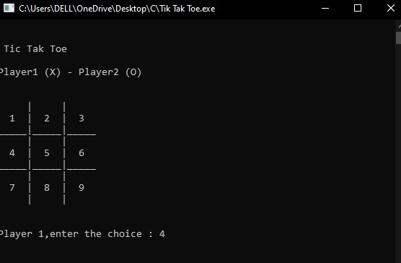 **OUTPUT**

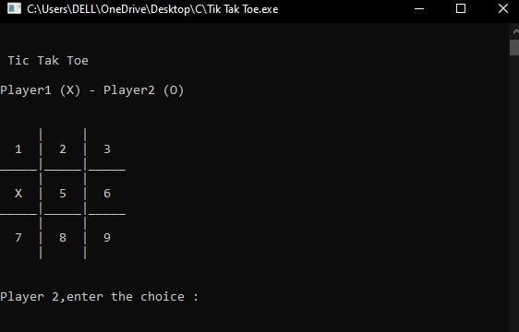

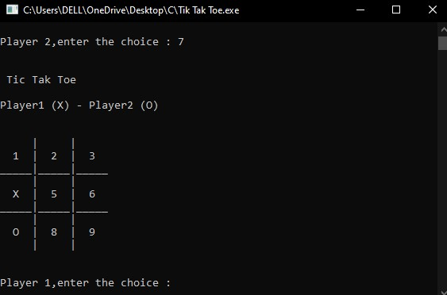

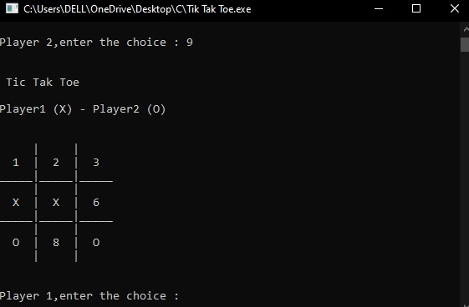

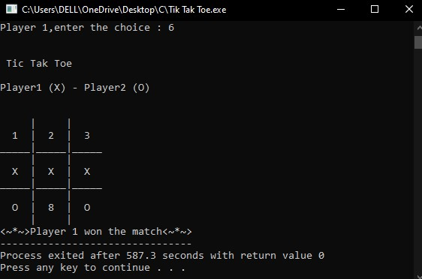

**CONCLUSION**

The application program has been successfully implemented using experimental cases and the language used – C. C. This application works for other functions that make it easy to search, delete, edit, and remember our peer information.

A Phone Book Management System In C++ or C is a console application without graphics. File handling and data structure concepts has been extensively used for almost all functions in this mini project.

# REFERENCE

 www.programming-techniques.com 

www.codewithc.com 

www.bestengineeringprojects.com  www.wikihow.com